**Competitive Assessment of the competitors**

**Competitor Personas**

1. **Background**

* History
* Location of stores
* Ownership
* Online presence
* Associated personalities

1. **Financial Performance**

* Profit growth
* Organic growth or through acquisitions

1. **Products and services**
2. **Marketing**

* Segments served
* Customer base
* Promotional mix
* Distribution channels
* Pricing and discount schemes

1. **Human resources**

* Personal strength
* Skill sets
* Management Strategies
* Compensation and benefits provided to the employees

**Note:** A broader competitive set is (direct and indirect competitors) for any venture.

**Differentiation Strategy**

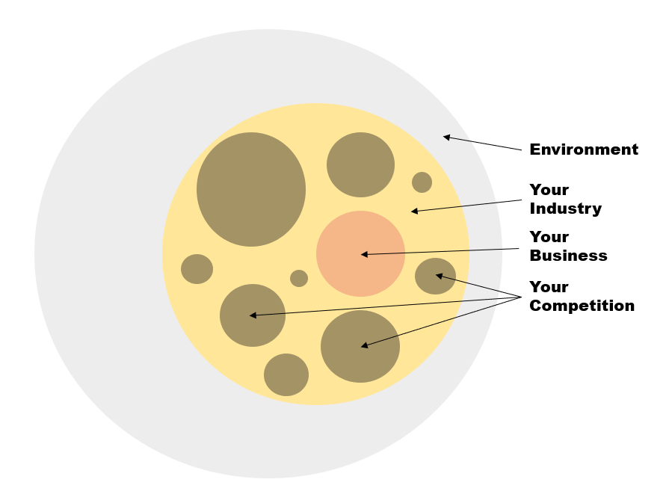

Now that you have zoomed in to your business and your competition, what would you do next? You, of course, need to maximize your chances of success against your competition.

A **differentiation strategy** is a way to undermine the competition by creating an offering that is perceived to be better than others in the market. After realising your competitive position in the market and the strengths (and weaknesses) of you and your competition, it is a must for an entrepreneur to create a strong differentiation in order to stay ahead of the crowd. If your differentiation strategy works, you may be able to charge your customers a premium for your product/service and create a sustainable advantage over your surroundings. This segment will help you formulate your differentiation strategy.

Service and innovation are the two key factors while starting out as a new player in the market.

Differentiation can be done using 4 P’s

1. Product
2. Price
3. Place
4. Promotion